NB.Sc Computer Games Development, Year 3, Project I

Game Design Document

29- Sept-2017

**“Celestial Ascension”**

Authors: Darren Sweeney, D.J. O’ Leary

Project Supervisor: Philip Burke

# 

Table of contents

Overview

The Elevator Pitch / High Concept

Theme, Setting and Genre

Player Experience Goals

View

Targeted platform(s)

Technical requirements(s)

GamePlay

The First Minute (60 seconds of play)

Game progression

Level progression

Objectives/Victory Conditions

Features

Power-Ups:

Firing:

Moving:

Particles:

Scoreboard:

Tech-Tree:

Enemy types:

8. Lighting

Game World

Game Setting

Game World Elements

Enemies:

Power-Ups:

Interaction with power ups:

Levels

Level description

Interface

Controls

In game overlays & dialogs

HUD

Screenflow

AI

Opponent AI

Game Art & Audio

Audio

Art assets

Characters

Items

Level backgrounds/maps/environment textures

Visual effects

Particles

HUD graphics, typeface

Controls screen/menu

# 

# 

# Overview

### The Elevator Pitch / High Concept

Celestial Ascension is a top down 2D arcade style shoot em up where players must survive a continuous variety waves of enemies using fast paced movement and power ups.

### Theme, Setting and Genre

The game will be set in space and will be a arena style top down shoot em up.

### 

### Player Experience Goals

Players will have to fight through a variety of different enemies with different movement sets. Players will feel a sense of frustration at times but when the player gets over the hurdle of defeating them the emotional reward will be greater. Being able to beat a wave of hard enemies will be more satisfying for the player. Percentage weights on enemy spawns should stop players from getting frustrated at certain waves, as it will be random.

### View

The game will have a top down perspective and will dynamically place the player within the screen depending on the player’s position.

### 

### Targeted platform(s)

32-bit Windows 7, Windows 8.1, Windows 10

### Technical requirements(s)

Game will be made with in SFML framework and using the graphics API OpenGL alongside C++. We want to game to have screen resolution independent rendering.

# GamePlay

### The First Minute (60 seconds of play)

After the title screen the player is presented with a menu where they can decide to go change options or play the game. If the player chooses the play option they can then choose to start the game or look at the high score table. After selecting an option to start a new game the game begins placing the player at the centre of the screen. The player uses the left analog stick to move around and the right analog stick to shoot the gun in the direction the stick was pushed.

The enemies move towards the player in a swarm trying to reach them. The enemies dissolve into more particles when shot. Each bullet that hits an enemy adds 100 - 500 points to the players hi-score multiplied by the multiplier on the HUD.

## Game progression

* + 1. The player will start from Wave 1. The waves will increase when the number of enemies have been destroyed for that wave.
    2. How does the game increase in difficulty? Each wave introduces more difficult enemies with different ability. Damage and Heath will change for the enemy increasing the difficulty to beat the wave.
    3. Discovering new types of enemies and figuring out how to overcome them

## Level progression

Destroying all the enemies without running out of lives will allow the player to go into the next wave.

## Objectives/Victory Conditions

Objective is to survive as long as possible to get try and achieve the highest score possible.

# 

# 

# Features

### Power-Ups:



Heart Power Up.

Gives more one extra live to the player.



Shield power up.

This will provide a shield around the player for a period of time.



Double bullet power up.

The double bullet power up will change the color of the player bullets to yellow and allow the player to shoot two bullets from their ship.

Each power up will have a protector ring around it to let to know player that the power up is on screen. The ring will slowly rotate so that the powers up don’t sit static on screen.

### Firing:

Not all bullets will have the same direction when fired, they will have a small offset to the players direction of shooting. This will provide a better feel to firing. We want to avoid simple straight firing in a single direction with consistent fire rate for the special weapons.

The player can shoot two types of bullets, the basic starting bullets which are white or the double doublets which are yellow. Below is a concept diagram illustrating the offset position and color.

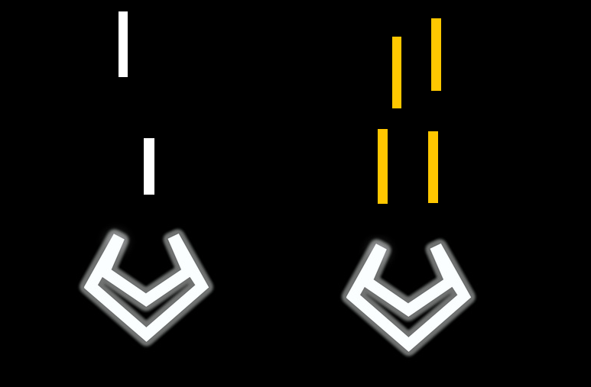

### Moving:

**Linear Movement:**

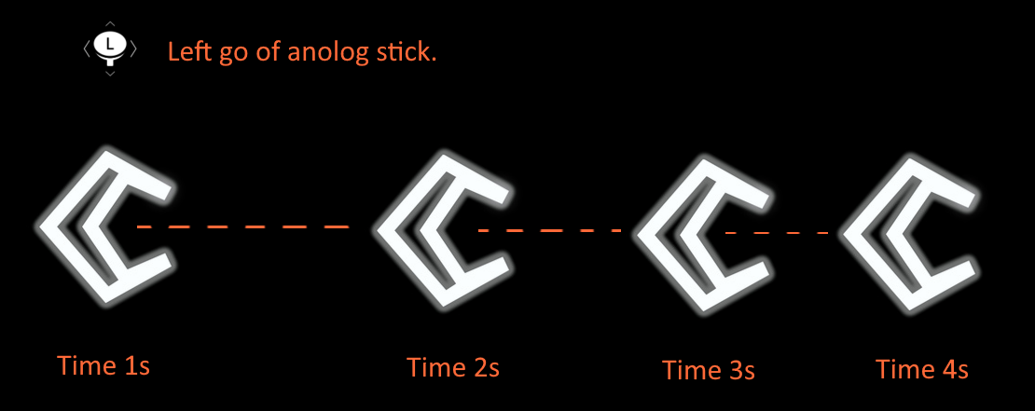

When the player leaves go of the controller the player will slowly decelerate and come to halt. Instead of the player instantly stopping when the left analog sticks is left go.

**Turn Movement:**

When the player makes a hard direction change in movement, for example instantly pushing the left analog stick from the far right to the far left we don’t want to rotation to instantly change. We want a gradually change in rotation to the target rotation of the control analog stick input. We also want to make sure this happens quick so the controls feel response and feel good but also not instantly as it would appear less fluid. We also get the benefit of adding more tension to gameplay where turning the away from the enemy has to be more timed than that having the opportunity the turn instantly away and always be safe from harm.

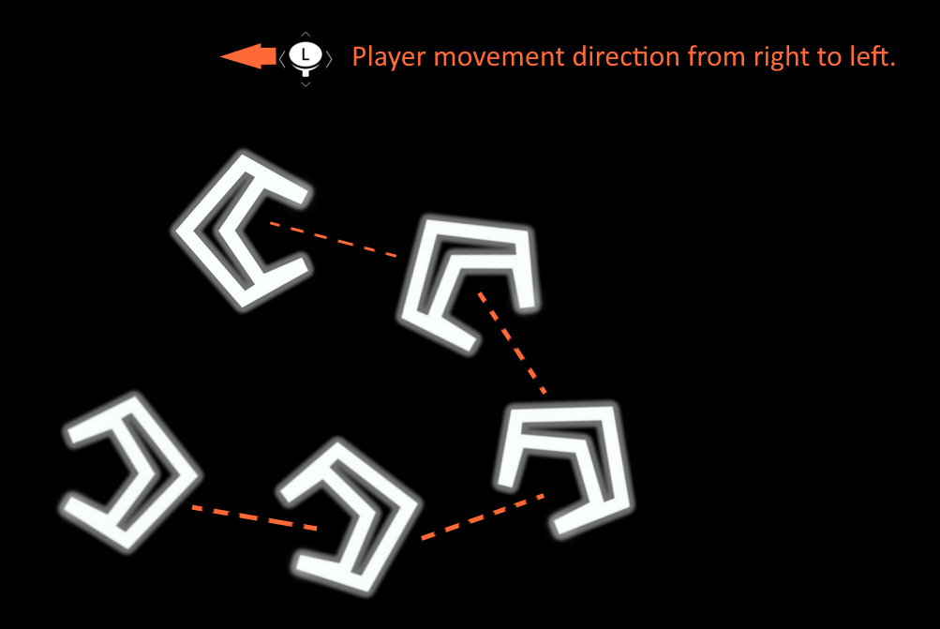

### Particles:

**Player exhaust particles:**

When the player moves there will be a stream of particles behind the player. Each particles will move out in a different directions while fading from bright orange/red to lower emissivity values to get a fade out look.



**Player & enemy explosion:**

When a player or enemy dies particles shoot out from the center point, each with different speed and opacity. We want to have a single color for each individual explosion. So when multiple enemies die there will be a lot of different colored explosion giving a vibrant look to the screen against a black background.

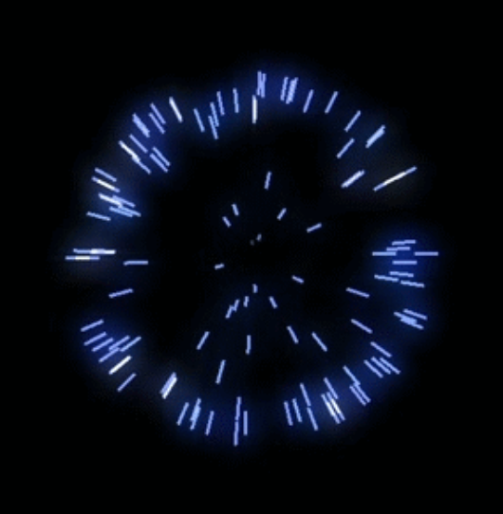

### Scoreboard:

The scoreboard will be a simply highscore table where the player's name and high score will be logged. The entries in the leaderboard will be saved on disk.

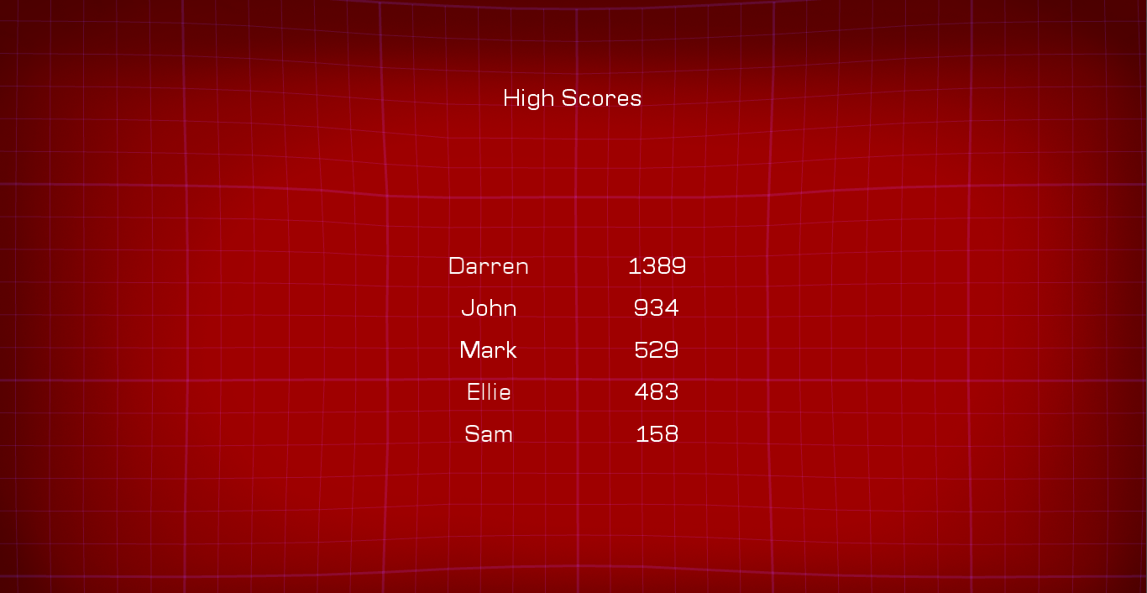

### Enemy types:

We have three different types of enemies, the “Wanderer” moves randomly around the grid as they wander around. The “Seeker” moves faster and is much smaller requiring the player to prioritize them before other enemy types, they chase after the player trying to touch them. The enemy blows up on impacts either hitting the player or getting shot. The “Turret” does not move, it just sits in one locations and shoots the player with it’s own bullets.

### 8. Lighting



# Game World

### Game Setting

The game is set in a vibrant space world with a grid placed over the game scene. This grid will react to player bullets and explosions from enemies in a wave like manner.

### Game World Elements

###### Enemies:

Wanderer

* *Moves towards a random point within the grid, picks a new point once it reaches its current one, looks like a glowing star shaped hexagon.*
* *If it touches the player the player loses a life.*

*Seeker*

* *Moves straight towards the player, looks like a triangle.*
* *If it touches the player the player loses a life.*
* *Uses its high speed and small size to get to the player.*

Turret

* *Stays still in it’s spawn location*
* Shoots the player at its last known location

# Levels

## Level description

The level layout will remain a constant throughout the game with the changing factor being the enemy types that appear each wave. Each wave will get progressively harder with more enemies being on screen at a time and the waves lasting longer due to increasing number of enemies.

# Interface

### Controls

Our game will use a classic twin stick shooter control scheme.

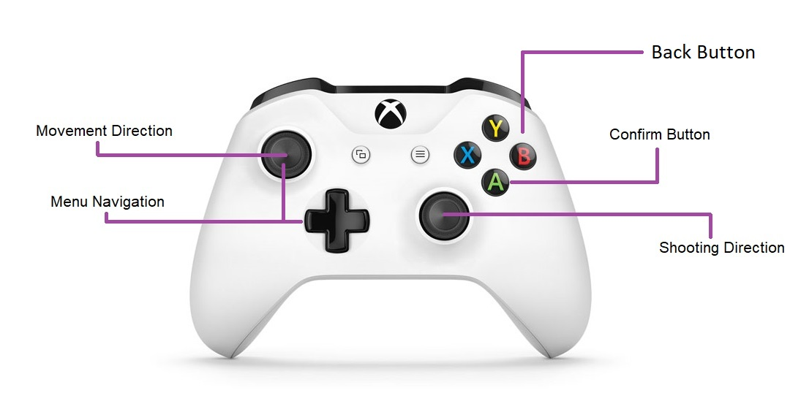

### In game overlays & dialogs

Main menu:

The player will use the D-Pad on the controller to navigate the menu. When the player reaches the end of the menu, i.e EXIT. The menu won’t cycle back to the top. Same with navigate to the top. The player can use the ‘A’ button on the xbox 360 controller to select the option on the menu. The grid in the background has forces put into it so that the menu doesn’t feel static

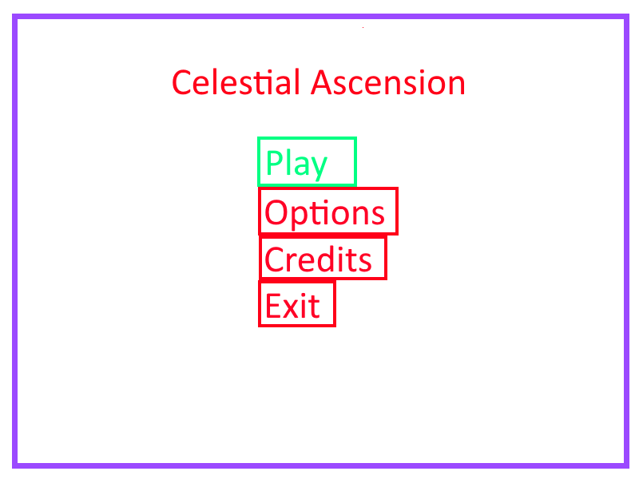

In Game HUD:

Multiple player actions are showcased in the in game HUD. The current enemy wave will be shown on the top right of the HUD. The number of lives of the player will be represented as pink hearts. If a player dies the HUD will update the HUD by decreasing the number of hearts on display. The current points the player has acquired from play will also show up. These points are persistent between rounds.

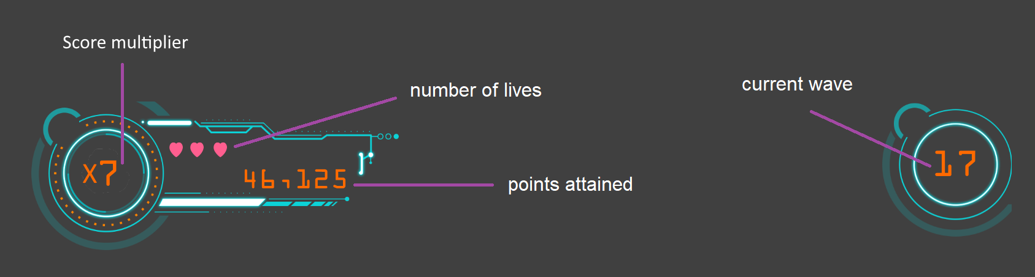

Enter name overlay

The player can enter their name if the have scored more that the minimum score on the leaderboard guaranteeing them a spot on the leaderboard. The player will have to enter their name with 3 characters displayed on screen. The player can change the representation of these character with 6 buttons which they can navigate to cycle up and down through each 3 characters. The button that the player is currently on will be highlighted in green and non-selected menu buttons highlighted in red.

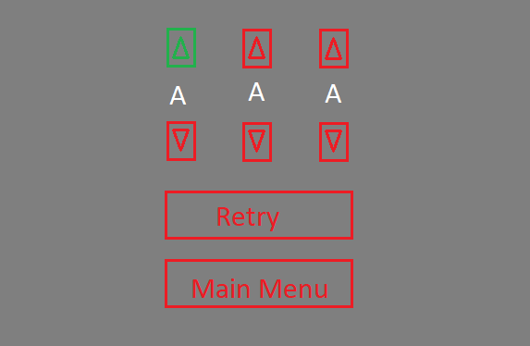

### Screenflow

*A graphical description of how each screen is related to every other and a description of the purpose of each screen.*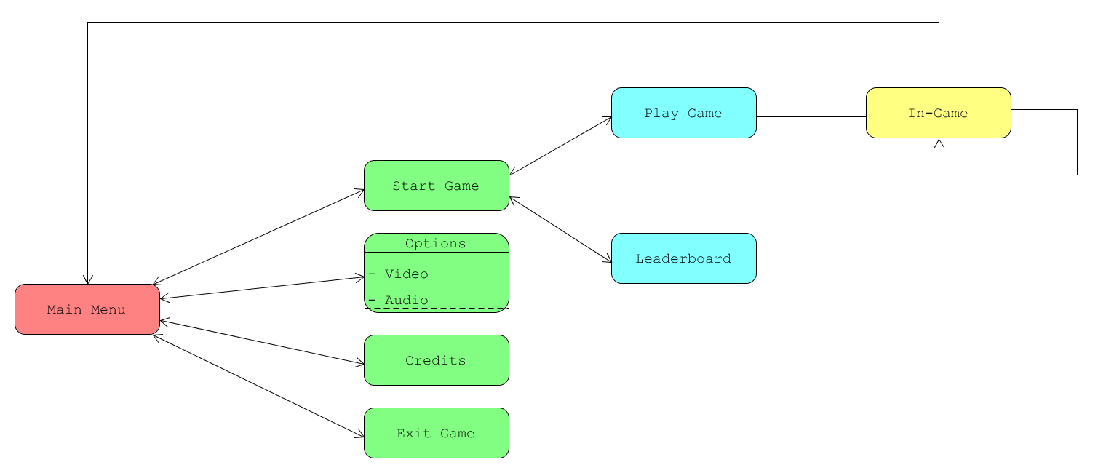

# AI[1]

## Opponent AI

*What strategic decisions do the NPCs need to make in order to defeat (or collaborate with the player.*

The enemy types each have a unique goal that they want to achieve.

* The “Wanderer” just wants to go to a random point it has picked within the play area, once they reach that point they pick a new point and head to that.
* The “Seeker” chases after the player.
* The “Turret” shoots at the player but is unable to move.

**General AI state machine diagram:**

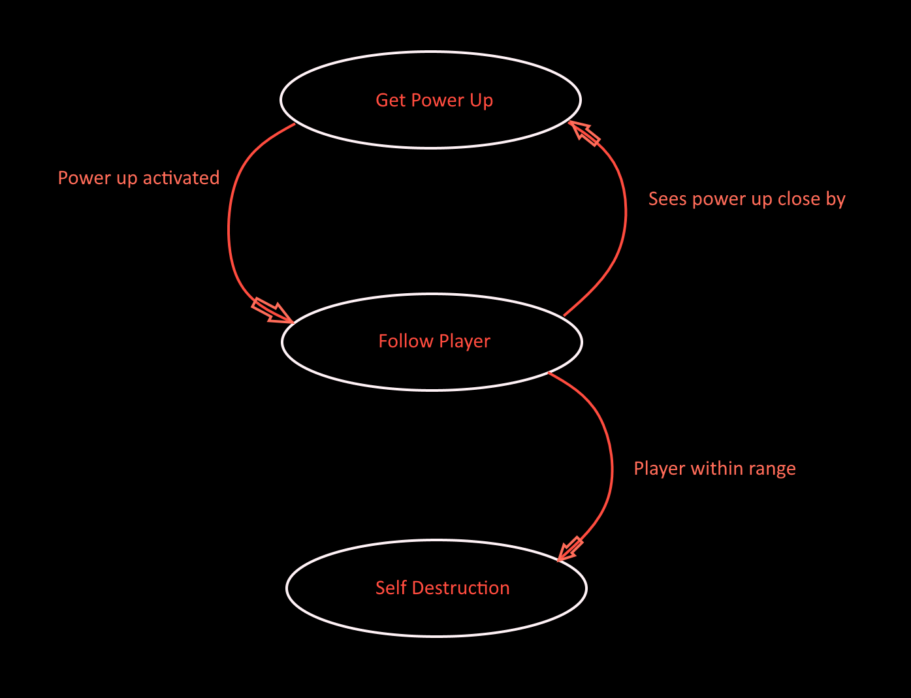

# Game Art & Audio

### Audio

Background music: [Link](https://drive.google.com/open?id=1tjdFQFbNZLjP3_0olW6PBvVtkLnsOEry)

Audio effects: [Link](https://drive.google.com/open?id=1qTC_9nQDEV_q01meaeI7SjQExPyDYr-a)

### Art assets

##### Characters

* Player: [Link](https://drive.google.com/open?id=17JnxP3Otw7iZLrj5ss2SkhH2i9PM8HBH)
* Seeker: [Link](https://github.com/ITCGamesProg2/project3-darren-dj/blob/master/project3_ds_dj/Assets/Seeker.png)
* Turret: [Link](https://github.com/ITCGamesProg2/project3-darren-dj/blob/master/project3_ds_dj/Assets/Turret.png)
* Wanderer: [Link](https://github.com/ITCGamesProg2/project3-darren-dj/blob/master/project3_ds_dj/Assets/Wanderer.png)

##### Items

* Power Ups: [Link](https://drive.google.com/open?id=17IHEgpOXzhsUoyeBmUlOAu35zr8vR1FV)
* Bullet: [Link](https://github.com/ITCGamesProg2/project3-darren-dj/blob/master/project3_ds_dj/Assets/Bullet.png)

##### Particles

* Particle Base: [Link](https://drive.google.com/open?id=0B6gny4LvztHhOFhTRlRUeWhEUHM)

##### HUD graphics, typeface

* HUD: [Link](https://drive.google.com/open?id=0B6gny4LvztHhUkNoN3BKRzM2Sk0)
* Font: [Link](https://drive.google.com/open?id=0B6gny4LvztHhYmpPenZaNG5Xc28)
* Heart: [Link](https://github.com/ITCGamesProg2/project3-darren-dj/blob/master/project3_ds_dj/Assets/HUD/heart.png)

##### Controls screen/menu

* Menu logo: [Link](https://github.com/ITCGamesProg2/project3-darren-dj/blob/master/project3_ds_dj/Assets/GameTitleLogo.png)
* Controller UI: [Link](https://drive.google.com/open?id=0B6gny4LvztHhUExoREN3V3lsNGc)
* Menu buttons: [Link](https://github.com/ITCGamesProg2/project3-darren-dj/tree/master/project3_ds_dj/Assets/GUI)

##### Splash Screen

* Splash screen logo: [Link](https://github.com/ITCGamesProg2/project3-darren-dj/tree/master/project3_ds_dj/Assets/SplashScreen)

1.